**Lab Cycle-1**

**Home Page**

<html>

<head>

<title> exp-1</title>

<img src="gitam-logo.jpg" height=85px width=280px>

</head>

<body>

<br>

<br>

<table">

<tr align=center>

<th><a href="home.html">Home</a></th>

<th><a href="login.html">Login</a></th>

<th><a href="reg.html">Registration</a></th>

<th><a href="catlg.html">Catalogue</a></th>

<th><a href="contact.html">Contact Us</a></th></tr>

</table>

<p>

Gandhi Institute of Technology and Management, popularly known as GITAM, was founded in 1980 by an inspired group of eminent intellectuals and industrialists of Andhra Pradesh led by Dr.M.V.V.S.Murthi, former Member of Parliament and popular philanthropist.The three cardinal principles of GITAM – strive, serve, thrive - encapsulate the quintessence of human life, that is, it is only through striving for the purpose of serving that one can thrive in life.

<br>

<br>

<u>ADMISSION NEWS</u>

<br>

<br>

<a href="http://www.gitam.edu/gat">GAT-2018: Admission to Engineering, Architecture and Pharmacy Programs - 201819</a>

<br>

<a href="http://www.gitambsms.in/">Bengaluru campus: MBA, BBA and MBA(I) Admissions 2018</a>

<br>

<a href="http://gsgs.gitam.edu/Downloads">GSGS Admissions - 2017 :Foreign Language courses</a>

<br>

<br>

<u>CAMPUS NEWS</u>

<br>

<br>

<a href="http://www.gitam.edu/images/campusnews/CertificateCourseinYoga.pdf">Certificate course in Yoga</a>

<br>

<a href="http://www.gitam.edu/images/campusnews/gitam-Volleyball-M-Team-17.pdf">GITAM Volleyball men team participating in the South Zone</a>

<br>

<a href="http://www.gitam.edu/images/campusnews/Revised-Academic-Calendar.pdf">Revised academic calendar for the year 2017-18</a>

<br>

</body></html>

**Login Page**

<html>

<head>

<title> login</title>

</head>

<body>

<img src="gitam-logo.jpg" height=85px width=280px></td></a>

<h2>Student Login Page</h2>

<table align=center>

<label>Username

<input type=text name=uname placeholder="Enter Your Regd no."></label>

<br>

<br>

<label>Password

<input type=password name=password placeholder=Password></label>

<br>

<br>

<input type=submit name=ok value=Login> <input type=reset name=reset value=Cancel>

</body>

</html>

**Registration Page**

<html>

<head>

<title>Registration form</title>

<img src="gitam-logo.jpg" height=85px width=280px></td></a>

</head><h2>Registration Details</h2>

<label>

Username <input type="text"/>

</label>

<br/><br/>

<label> Password<input type="password"/>

</label>

<br/><br/>

<label>Gender: Male: <input type="radio" name="geder"/>

Female: <input type="radio" value= name="gender"/><br/>

</label>

<br>

<label>Mobile Number: <input type="text" />

</label>

<br/><br/>

<label>Email-id : <input type="text" />

</label>

<br/><br/>

<label>Date of Birth : <input type="date" />

</label><br/><br/>

<label>

Course : <select name="courses">

<option value="">CSE</option>

<option value="">ECE</option>

<option value="">CIVIL</option>

<option value="">MECH</option>

<option value="">IT</option>

</select>

</label>

<br/><br/>

<label>Location : <select name="city">

<option value="ongole">Ongole</option>

<option value="delhi">Delhi</option>

<option value="mubai">Mumbai</option>

<option value="bglr">Banglore</option>

<option value="">others</option>

</select><br/><br/>

</label>

<label>Address : <textarea name="address" rows="5"></textarea>

</label><br/><br/>

<input type="button" value="Submit"/>

<input type="button" value="Reset"/>

</body>

</html>

**Catalogue Page**

<html>

<head>

<title>Catalogue</title>

<img src="gitam-logo.jpg" height=85px width=280px></td></a>

</head>

<body>

<h3><u>Description of Departments</u></h3>

<ul><ol type="i">

<li>CSE</a></li>

<li>IT</a></li>

<li>ECE</a></li>

<li>MECH</a></li>

</ol>

<dl>

<li><dt>CSE</a></dt>

<p id="CSE">

The department of Computer Science and Engineering was established

in the year 1986. The department is committed to imparting quality

education and producing highly skilled graduates who are in demand in the industry.

Currently, the department offers B. Tech. (Computer Science & Engineering),

M. Tech. (Computer Science & Technology) and Ph.D. Program along with

Certificate Programme on Programming in Python.</p></li>

<li><dl>

<dt>ECE</a></dt>

<p id="ECE">

The department started in the year 1981, became autonomous in 2003 and evolved as a constituent department in GITAM Institute of Technology, GITAM from 2007. The department is NBA accredited twice in the years 2002 and 2006. Students passout from this department with good placements and progression statistics.

The department has highly qualified faculty with high retention and varied specializations. It is well equipped with State-of-Art Laboratories.</p></dd></li>

<li><dl>

<dt>IT</a></dt><br>

<p id="IT">

Established in the year 2000 , the department of Information Technology offers B.Tech (IT), M.Tech (IT) and Doctoral programme. All the programs of the department are accredited with ‘A’ grade by NAAC. The curriculum is designed to cater the needs and demands of IT industry.

The department has 1200 undergraduate students , 60 Postgraduate students and 43 research scholars working under department faculty. The department has state–of-art labs and infrastructure to facilitate students in acquiring hands on experience in addition to classroom teaching.</p></dd></li>

<li><dl>

<dt>MECH</a></dt><br>

<p id="MECH">

Mechanical Engineering Department is one of the oldest departments in GITAM, Established in the year 1980. Mechanical Engineering is one of the major activities in the engineering profession and its principles are involved in the design, study, development and construction of nearly all of the physical devices and systems. Continued research and development have led to better machines and processes helping the mankind.</p></dd></li>

</dl></ul><br><br></body>

</html>

**Contact Page**

<html>

<head>

<title>Contact Us</title>

<img src="gitam-logo.jpg" height=85px width=280px>

</head>

<body>

<h2>Contact Us</h2>

<label>

Name <input type="text"/>

</label>

<br/><br/>

<label>Mobile Number: <input type="text" />

</label>

<br/><br/>

<label>Email-id : <input type="text" />

</label>

<br/><br/>

<label>Address : <textarea name="address" rows="5"></textarea>

</label><br/><br/>

<input type="button" value="Submit"/>

<input type="button" value="Reset"/>

<h3><u>For any Further Details</u></h3>

<li>Phone No: (+91-891) 2840 501</li>

<li>Fax: (+91-891) 2795 311</li>

<li>Fax: (+91-891) 2795 311</li>

</body>

</html>

**Home Page**

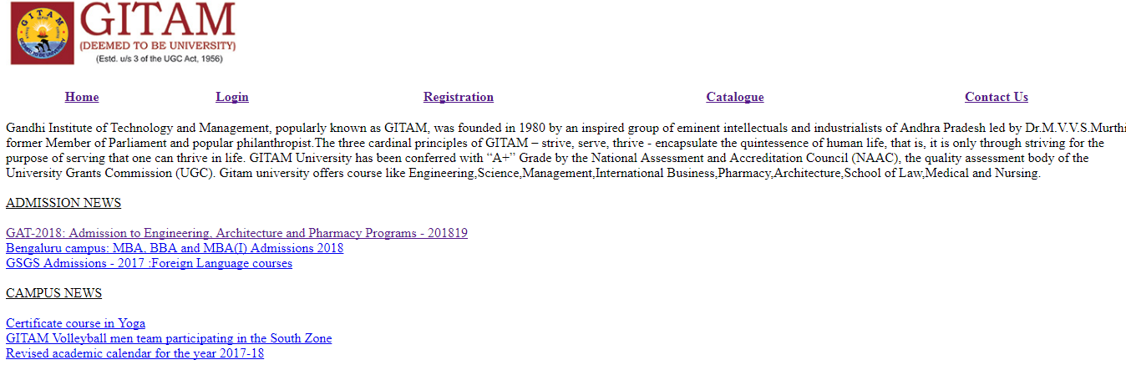

**Login Page**

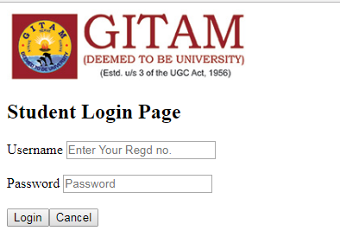

**Registration Page**

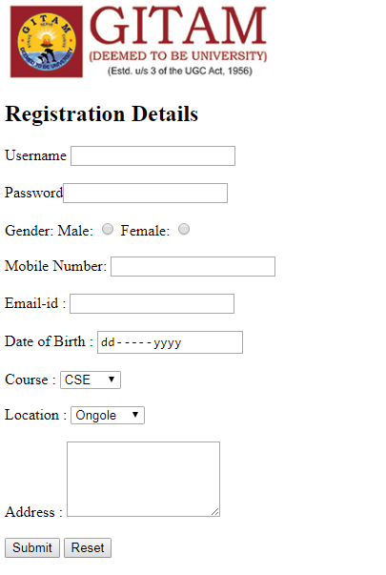

**Catalogue Page**

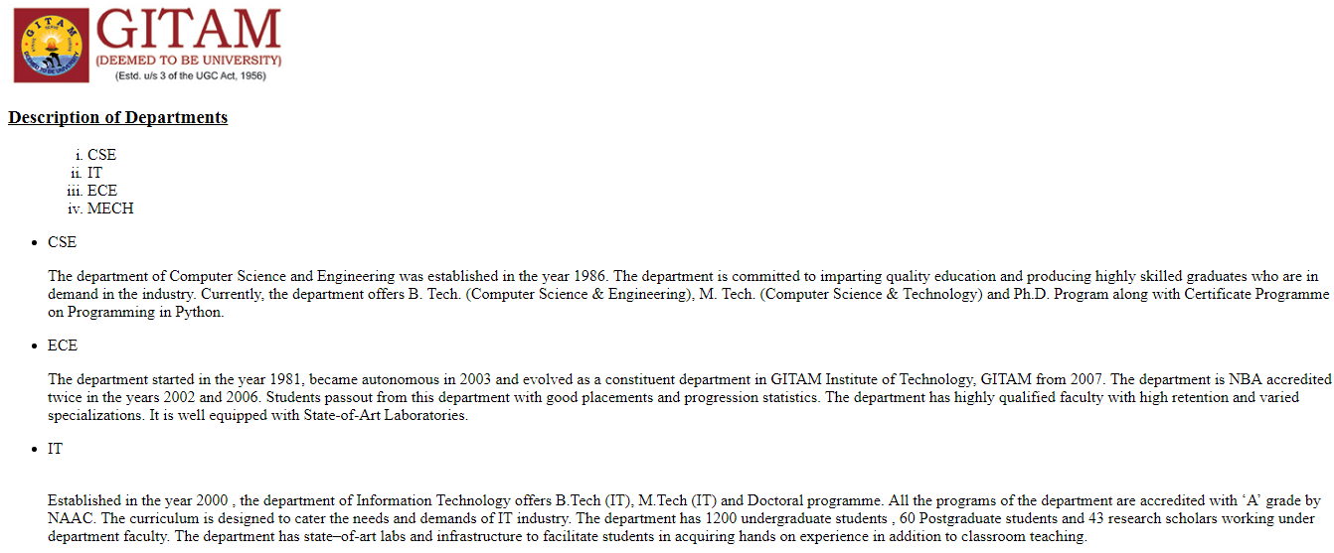

**Contact Us**

